Disclaimer
This program is free software: you can redistribute it and/or modify it under the terms of the GNU General Public License as published by the Free Software Foundation, either version 3 of the License, or (at your option) any later version.
This program is distributed in the hope that it will be useful, but WITHOUT ANY WARRANTY; without even the implied warranty of MERCHANTABILITY or FITNESS FOR A PARTICULAR PURPOSE.
See the GNU General Public License for more details.
You should have received a copy of the GNU General Public Licensealong with this program. If not, see <http://www.gnu.org/licenses/>.

In using the product you accept that the entire risk is borne by you.
To the maximum extent permitted by law, all liability is excluded for claims, expenses, losses, damages and costs made against or incurred or suffered by you or anyone else directly or indirectly arising out of:
- Use of the software product
- Inability to use or obtain access to the software product
EXploringEA IS NOT RESPONSIBLE FOR ANY INDIRECT, SPECIAL, INCIDENTAL, OR CONSEQUENTIAL DAMAGES OF ANY CHARACTER INCLUDING, WITHOUT LIMITATION, DAMAGES FOR LOSS OF GOODWILL, WORK STOPPAGE, COMPUTER FAILURE OR MALFUNCTION, OR ANY AND ALL OTHER COMMERCIAL DAMAGES OR LOSSES.

Changes in V3
- Additional registry locations checked for add-in keys

Changes in V2
- Searches HKLM for Sparx keys as well as HKCU
- Pop-up added to make it easier to read

Purpose
EA Installation Inspector is a small utility for developers to search the registry to check information about current EA AddIn’s.

Running eaInstallationInspector
The program is a windows application that will present the user with basic information about the installed environment and version together with a list of the EA Addin keys found in the registry with details of the relevant classes/DLLs - similar to the screen shot below.
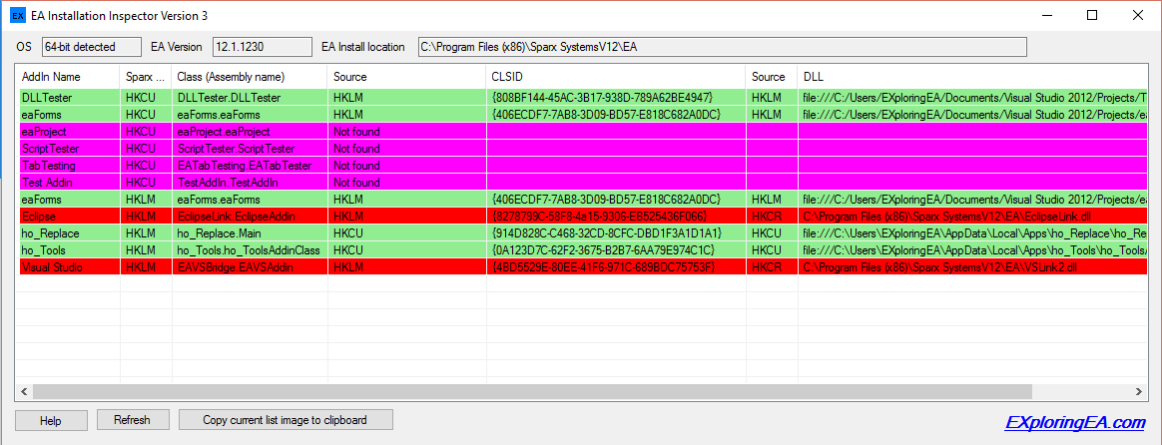
Each row represents an AddIn entry – and for a valid entry will display all of:
- The AddIn Name
- The location of the Sparx AddIn key within the windows registry
- Class(Assembly name) - Addin entry class
- (CLSID ) Source – the location where the ClassID is defined in the registry
- CLSID – Class ID – as defined when the class was registered
- (DLL) Source – the location where the DLL is defined in the registry
- DLL – Full file name for the AddIn DLL

In some cases, and as illustrated in the screen shot not all entries are complet; it may be that the AddIn is working or correctly installed and to help see any issues each row is coloured to reflect the status of the entry.
- Green – OK - the AddIn DLL has been found and the keys exist in the same hive; we assume that AddIn will be found by EA.
- Cyan – indicates that all the keys look file but the DLL file does not exist at the specified location
- Magenta – means that no Class ID is set for the AddIn, hence the DLL cannot be indentified
- Red – indicates that CLSID and DLL are specified in different registry Key Sections
- Yellow – means that the DLL path is not set so cannot be found

Functions
The program will automatically perform the search and present the list of AddIn’s when run. The following functions are available by accessing the buttons at the bottom of the screen dialog.
- Help – will present this document
- Refresh – will redo the search to reflect any changes that the user many have made to their system
- Copy current list image to clipboard – will copy the current list as an image to the clipboard for those times when the user may wish to forward to others.
- EXploringEA.com – will launch the default web browser with our blog page. You can also find contact information on this site should you wish to contact us

Pop-Up for Single entry
It can sometimes be difficult to see all the information in a row so you can now double_click an entry and a form (similar to that illustrated below) is presented with the values more readily seen.

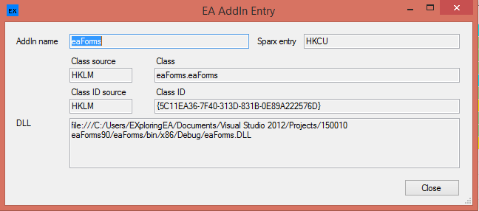

Assumptions and method
As we don’t have access to the Sparx Code which loads the AddIn’s, it is assumed that AddIn’s registry keys are specified in locations under "Sparx Systems\EAAddins" within either in HKCU or HKLM in the registry.
Using the list of Addins found in those locations we use the the list of classes and search in the registry to find the related classes and their DLL’s. The searches for the CLISD and DLL are restricted to HKCU and HKLM.
The output of the program is a list of AddIn’s as detailed above and illustrated in the screen shot above.

